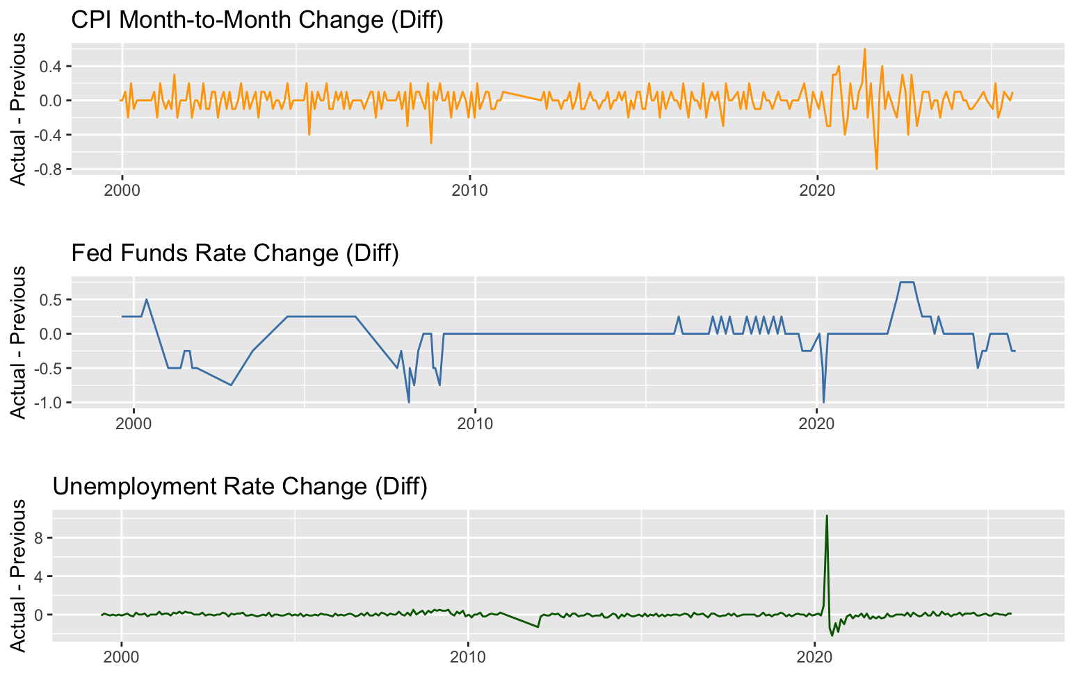
CPI Month-to-Month Change (Diff)
What the plot shows
This plot displays the month-to-month change in the Core CPI (Actual − Previous) from 1999 to 2025. Each point shows how much inflation changed from the prior month.
Interpretation
CPI changes are very small and stable, almost always between −0.2 and +0.2. This indicates that inflation moves gradually, with very few large shocks. Notable drops occur during financial crises (2008) and the COVID period (2020), but otherwise CPI is smooth and predictable. Because CPI changes are so modest, their impact on market volatility is likely weaker and more subtle compared to the Fed announcements.
Fed Funds Rate Change (Diff)
What the plot shows
This plot shows month-to-month changes in the Federal Funds Rate determined by the Federal Reserve, represented as Actual − Previous across Fed meeting dates.
Interpretation
Fed rate changes are infrequent but large. Long stretches of zero change are followed by sudden rate hikes or cuts, especially around recessionary periods (early 2000s, 2008–2009) and during the COVID crash (2020). These “jump” behaviors indicate that Fed decisions introduce significant shocks into financial markets. This makes the Fed Funds Rate one of the most influential macro indicators for market volatility.
Unemployment Rate Change (Diff)
What the plot shows
This line plot shows the month-to-month change in the U.S. unemployment rate from 1999 to 2025.
Interpretation
Unemployment changes are extremely stable, typically moving only ±0.1 month-to-month. The single massive spike in 2020 reflects the COVID employment crisis, where unemployment rose sharply in one month. Outside of this event, unemployment tends to change very slowly. Because unemployment rarely jumps, it likely has the weakest short-term effect on SPY volatility except during extreme economic disruptions.
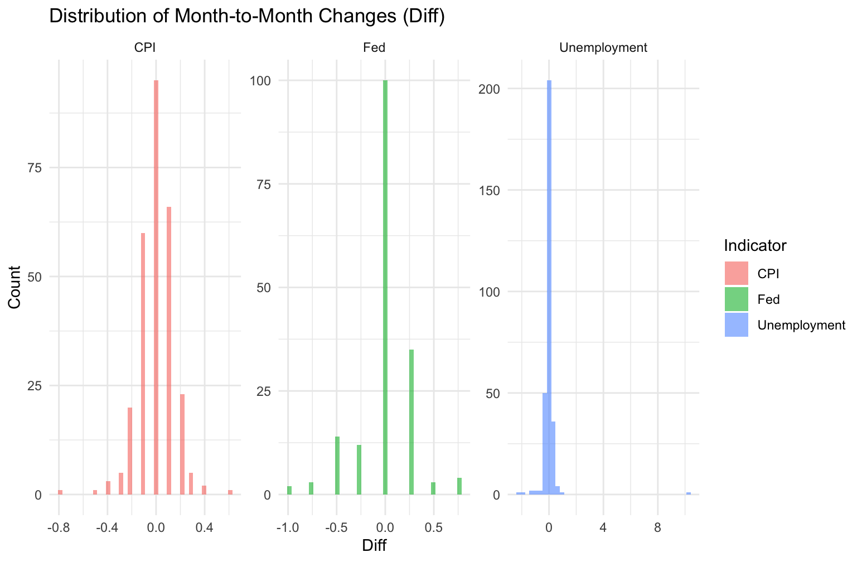
Distribution of Month-to-Month Changes (Histograms)
What the plot shows
Three histograms (CPI, Fed, Unemployment) visualize the distribution of their Diff values (Actual − Previous).
Interpretation
- CPI: Very tight symmetric distribution around zero, indicating consistent and predictable monthly changes.
- Fed: Clustered at zero, with occasional strong positive or negative changes, showing the Fed creates discrete shocks.
- Unemployment: Extremely concentrated at zero except for a few rare large jumps, especially the COVID spike.
These distributions highlight that macro indicators have very different statistical behaviors, supporting treating them as separate predictors in the model.

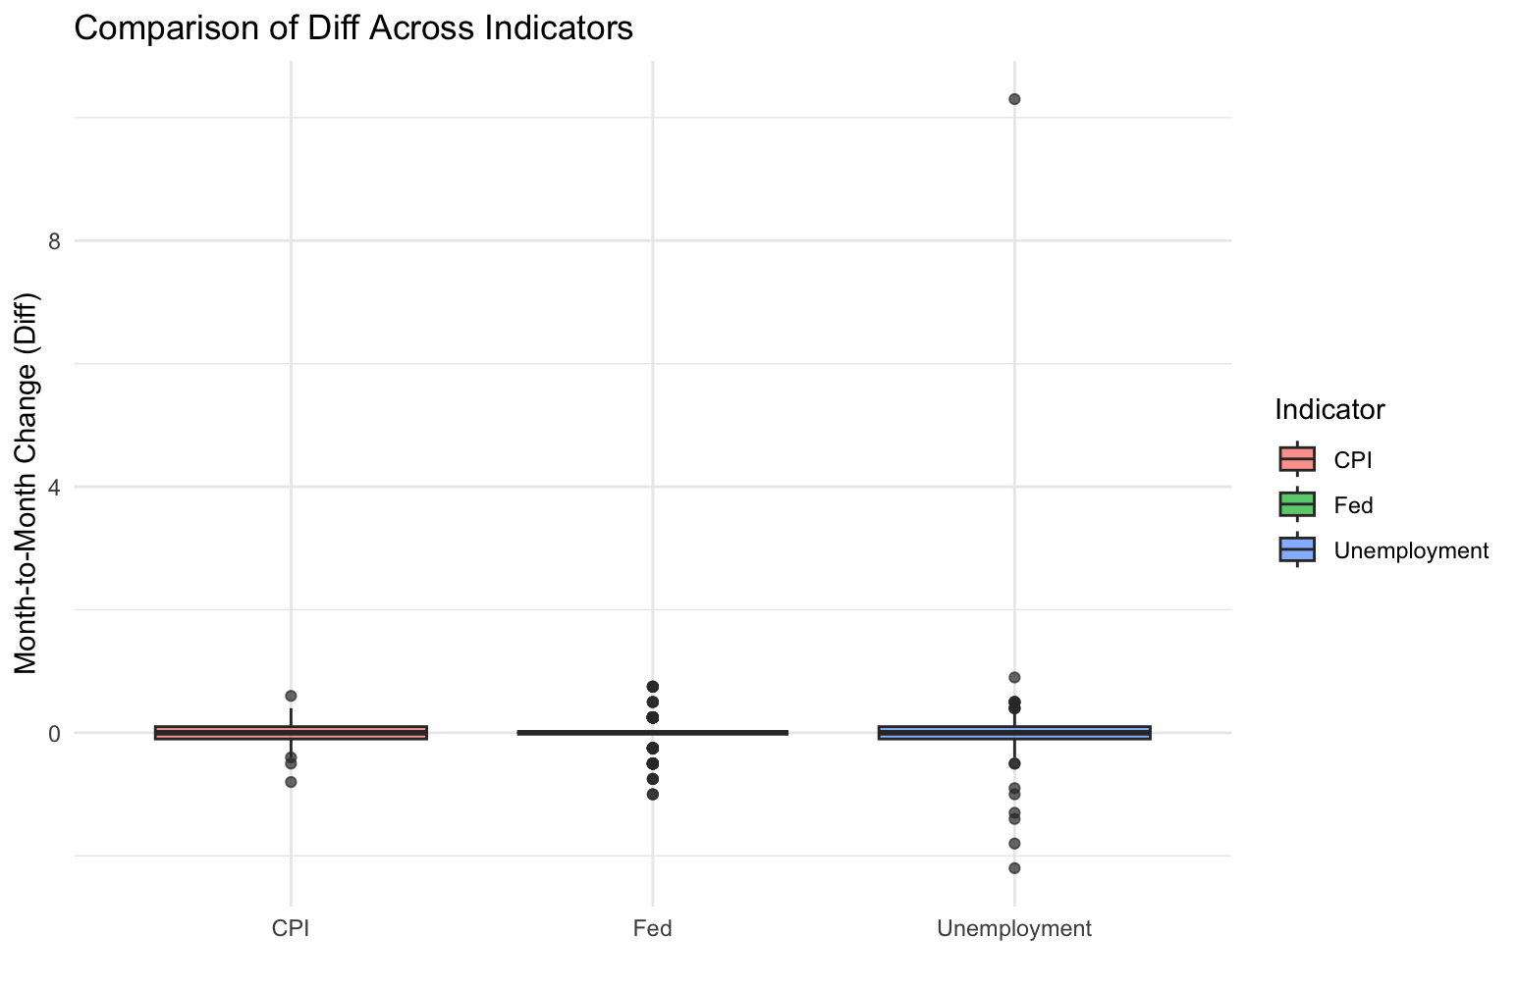
Boxplot Comparison Across Indicators
What the plot shows
This boxplot compares the variance and outliers in Diff across CPI, Fed Funds Rate, and Unemployment Rate.
Interpretation
CPI has the smallest range with minimal outliers, reflecting stable inflation. The Fed series shows larger spread and multiple outliers, indicating significant rate adjustments. Unemployment has one extreme outlier (COVID spike) but otherwise behaves similarly to CPI. These differences confirm that each macro indicator has a distinct volatility pattern, which directly affects how markets respond to each announcement.

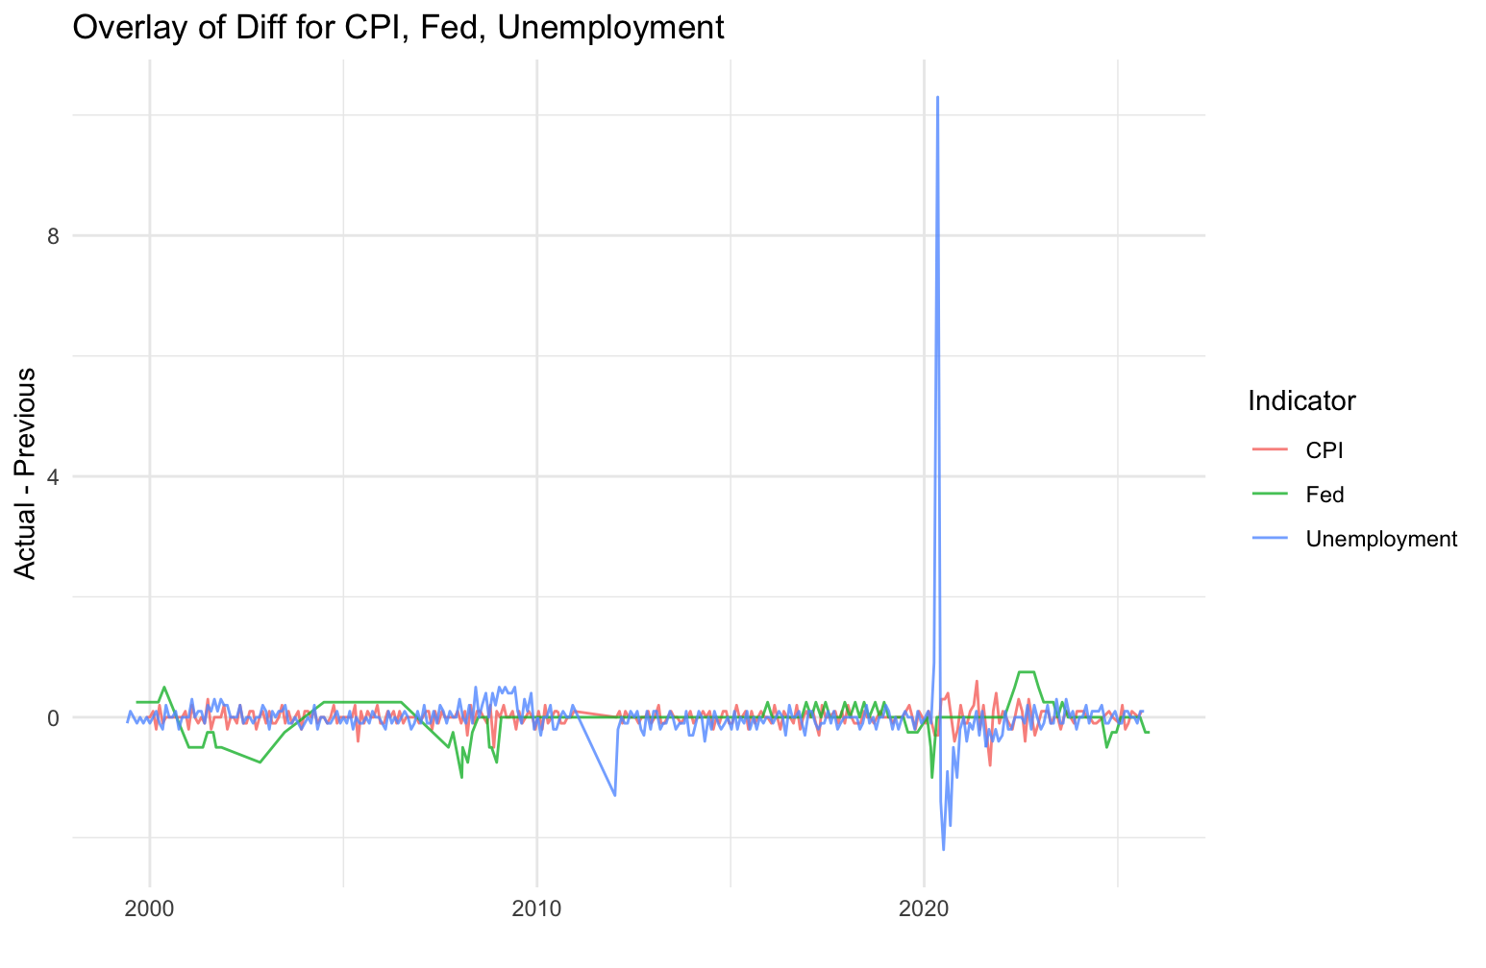
Overlay of Diff for CPI, Fed, and Unemployment
What the plot shows
All three Diff series are plotted together to show how they behave over time and relative to each other.
Interpretation
All three indicators remain close to zero most of the time, but the Fed series exhibits sudden jumps, and unemployment has one massive spike in 2020. CPI fluctuates within a very narrow band. The overlay makes the structural contrast clear: Fed decisions cause jump shocks; CPI is smooth and stable; unemployment is stable except in crisis conditions. This difference justifies comparing their individual effects on SPY volatility.

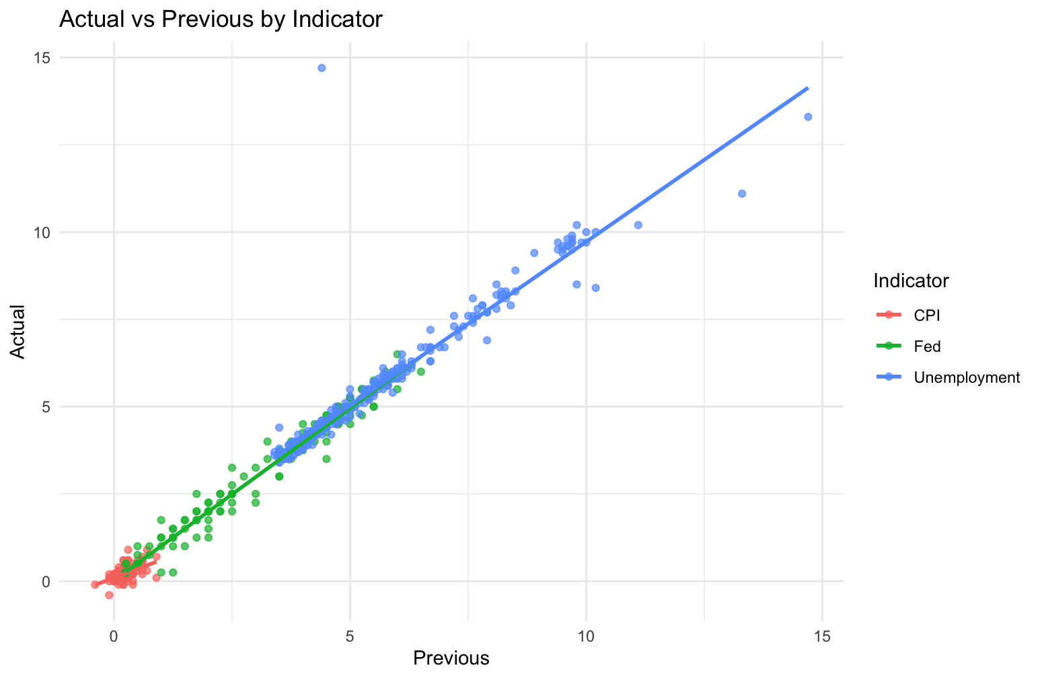
Actual vs Previous Scatterplot
What the plot shows
This scatterplot shows the relationship between the current month’s value (Actual) and the previous month’s value (Previous) for CPI, Fed, and Unemployment.
Interpretation
All three indicators lie almost perfectly along a 45-degree line, meaning Actual ≈ Previous for most months. This strong autocorrelation confirms that these macroeconomic indicators move slowly over time, with rare large jumps. Because of this, the month-to-month difference (Diff) captures essentially all meaningful new information, validating its use as the key predictor in the volatility model.

